INTRODUCTION TO ELECTRICAL CIRCUITS LAB FINAL TERM QUIZ//Time: 1.5Hr// Marks: 40

1. Oscilloscopes considered one of the most common measuring instruments in engineering field. It has application in electrical, mechanical, civil, computer, communication, biomedical and almost in every sector. We can measure different type of properties of wave through oscilloscope. Please discuss how we can find out these properties through oscilloscope in a detail manner: **peak voltage, peak to peak voltage, RMS value, Average value, Crest factor, Quality factor, Time period, Frequency, Amplitude, Cycle, Angular frequency [**Don’t copy paste from internet. Write in your own sentence format.]
2. Solve this RLC Network by using software and by theoretical calculation. Make a comparison between them.

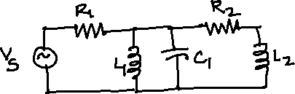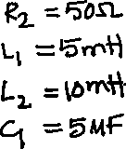

Find the total current and voltage across each component to this network.

## Vs value will be changed based on your ID value. You will take last 2 digit

of your ID value. Say for example, if your ID is 18-23456-2… you will take 56

from here, so Vs will be 156 volt.

## For Simulation please use screen shot of the software.

1. Please discuss the importance of resonance in communication circuit. Don’t copy paste from internet. Write in your own sentence format.
2. Discuss about the steps to select power factor correction device for a residential building. Don’t copy paste from internet. Write in your own sentence format.

**\*\* Please Submit in DOC/PDF format.**